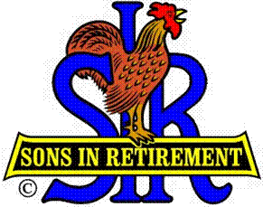

Las Trampas Branch 116

Luncheon Meeting Agenda

February 19, 2018

11:30 AM
- Call to Order – Big Sir.
- Welcome
- Pledge of Allegiance.
- Invocation & Story: Michael Barrington
- Introduce Head Table
- Little Sir: Jerry Hicks
- Guest Speaker – Michael Butler, Lesher Center for the Arts
- Introduce Guests & Visitors
- Guests:
- Past Big SIRS – Please Stand to be recognized
- 2017 New Members please rise and introduce yourselfs.
- Visitors:
- Introduce New Members
- Big Sir Comment
- Relinquish my time for Golf Presentations after Lunch
- I will not attend the March 19 meeting. Little SIR Jerry Hicks will take my place.

11:45 PM – Lunch
- Raffle Drawing
- Sunshine Report

12:15 PM
- Committee Reports and Golf Presentations
- Golf Presentations, Bernie Wroblewski, Commissioner and Dick Chaffee, 9 Hole Group

12:30 PM
Little Sir:
- Introduce Guest Speaker – Michael Butler
- Ask February Birthday guys to stand / sing Happy Birthday (Paul King & Robbie)
- Sign God Bless America.

